15.49: a) Speed in each segment is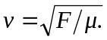 The time to travel through a segment is 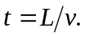 The travel times then, are 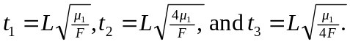 Adding gives 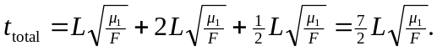

b) No, because the tension is uniform throughout each piece.

